2027 STATE HAWAI’I SENIOR SOFTBALL TOURNAMENT
RULES AND REGULATIONS

1. FIELD REQUIREMENTS

1.1 Distance between bases: 60 feet (measured from the tip of home plate to the outside corner of first base)

1.2 Distance to pitcher’s mound: 46 feet (measured from the forward edge of home plate to the forward edge of the pitcher’s plate). A pitcher will pitch with one foot within the pitcher’s box upon delivery from a distance measuring 46 feet to 56 feet from home plate.

1.3 The strike mat, measuring 19 inches wide by 34.5 inches long, will be placed over home plate and be aligned with the front edge of home plate. DEFENSE: A defensive player making a play at home will be allowed to complete the play by touching any portion of the strike mat. If a defensive player kicks or moves the mat during the play the runner scoring will be declared safe.

1.4 A strike is a legal pitch touching any part of the strike mat.

1.5 DOUBLE BAGS: Double bags at first base shall be used for league and tournament play. A double bag (hereafter referred to as the “inner” or “outer” bag or “base”) of equal size shall be used at first base. The outer bag shall be placed in foul territory abutting first base. If there is a play on a batter-runner going to first base, the batter-runner shall touch the outer base and, if not, shall be declared out unless in the Umpire’s judgment the batter-runner is avoiding a collision.

After the batter-runner has safely reached first base, the double base is treated as one base and the fielder or runner may use any portion of the double base.

1.6 The host island for the State Tournament shall mark the perimeter of all fields that do not have a perimeter fence. The marked fields shall have a 250 feet radius where applicable.

1.7 SCORING LINE: Refer to Diagram located in Rule Book

The scoring line shall be placed with the line beginning 8 feet from the forward left corner of the home plate (strike mat). The scoring line shall be situated on an imaginary extension perpendicular to the third base foul line.

A base runner’s foot down on or down past the scoring line prior to the ball being received by a defensive player touching the home plate (strike mat)
shall result in the scoring of a run.

    - TWENTY (20) F00T LINE:

- A 20-foot line measured from the tip of home plate towards third base will be used for all tournament games.

- At the spot marking the 20 foot distance, there will be another commitment line approximately six (6) feet long intersecting the runner’s line. (Three feet on each side of the runner’s lane)

- For this rule, any base runner that either touches this line or passes this line is committed to home plate and the play will be considered a force play at home plate. A player who has one foot down on or down past the commitment line cannot be tagged out. A player who re-crosses the commitment line back to third base will be declared out.

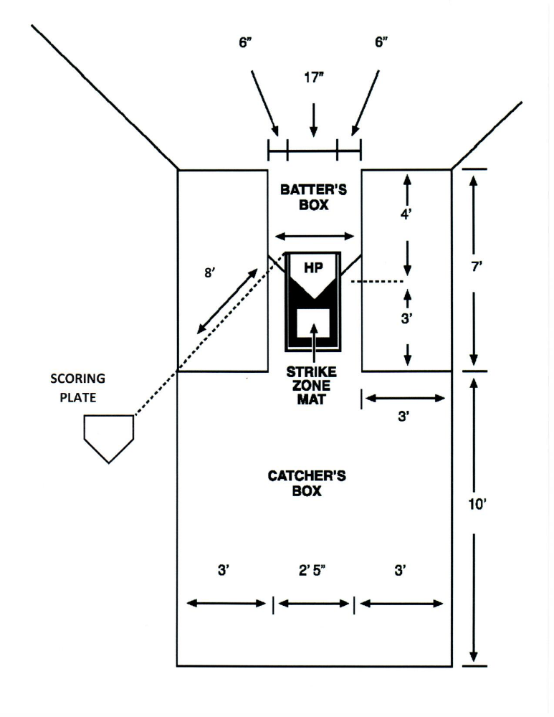

2. OFFICIAL BALL

2.1 Fourteen (14) inch inseam type balls shall be used for all games during the tournament.

2.2 The host island shall keep all tournament balls after completion of games.

3. GAME LENGTH, RUNS, TIES

3.1 An official game must be not less than four and a half innings if the home team is ahead.

3.2. A 12-run TKO rule will be in effect for all games except for CHAMPIONSHIP GAMES. However, teams must complete five (5) innings of play or 4 ½ innings if the home team is ahead.

3.3 After 60 minutes has expired, that inning will be completed and one additional inning will be played. There will be no time limit and no run limits in championship games. Time outs taken for injuries, protests, or weather delays shall be excluded from the 60 minutes allotted play time during tournaments. Official scorekeepers shall ensure that the time clock is stopped and re-started in accordance with this rule.

If, in the Umpire’s judgment, a team is intentionally delaying play to manipulate the time clock the Umpire may issue a warning. Additional delays may be cause for the umpire to call a ball on the pitcher.

3.4 A fifteen minute grace period may be permitted for the first game only. When there are multiple games on a specific field, teams scheduled to play shall be ready to play their game not less than 30 minutes prior to the scheduled game.

3.5 Except as otherwise provided, there shall be a maximum of five (5) runs per inning, except for the final inning of the game in which each team can score an unlimited number of runs. The umpire shall announce the last inning unless it is the seventh inning.

3.6 When teams are tied and going into extra innings, each team starts each inning with a runner on second base. The runner must be the last person who batted the previous inning, whether he/she made the third out or not and no substitute or courtesy runner may replace him/her until he/she has reached third base. NOTE: If the last player at bat cannot continue to play due to injury, illness, etc., he/she will be declared out and the next previous batter will be the tie-breaker runner.

3.7 The Chief Umpire shall declare the starting time right after the first pitch.

4. PLAYER ELIGIBILITY

4.1 All players must be 55 years and older to participate and shall only be added to a team’s roster upon reaching the age of 55.

4.2 For purposes of these rules, the term “under 60” shall refer to players 55-59 years of age. Teams may exercise their option to use male and female players under 60 years of age provided that only one male under 60 shall be used in a single game. A female player under 60 shall be considered and treated as a 60 year old player.

4.3 Substitution rules governing players under the age of 60. A male player under 60 years of age can only substitute for another under 60 player in the lineup and must bat in the same position. A substitution for a female player under 60 must be by a female 55 years or older or by a male 60 years or older.

EXCEPTION: If a team’s starting lineup does not include a player under 60 years of age, an under 60 substitute may be inserted in any part of the batting order. However, if a second under 60 substitute is used, he/she can only substitute and bat in the same order established by the first under 60 substitute.

4.4 Eligibility Based on Year of Birth: A player who will attain the age of 60 during the year is considered to be 60 years of age and is eligible to play for the calendar year.

4.5 A player must participate in a minimum of 5 regular season games to be eligible to play in the state tournament.

4.6 Every player in the state tournament must participate in one game of pool play in order to play in the championship round.

5. ROSTERS

5.1 There is no limit to the number of players on a team’s roster.

5.2 Final and complete rosters must be submitted to the Host Island no later than July 1 of the year of the tournament, provided that teams who add players in accordance with Rule 5-4 must submit an amended roster to include the added players no later than July 31 of the current year.

5.3 All players must sign the roster forms to verify their ages.

5.4 All players listed on a team’s roster must have been active with the team during the current season. “Active” shall mean that the player has been on the team’s roster from the beginning of the season or added in compliance with the island’s home rules. A team lacking sufficient players for the state tournament may add players to their roster. A team lacking sufficient players may add players to their roster from teams that were dissolved during the regular season or from teams of equal or lower standings who are not participating in the state tournament. The addition of these players shall be no later than the last day of the island’s softball season. Upon approval of Island Coordinators, these names must be highlighted when State tournament rosters are submitted.

A player who plays in multiple leagues or teams during the regular season shall play on only one team at the state tournament.

5.5 THERE WILL BE NO ALL STAR TEAMS. Teams entering the tournament will use only their original players in the existing league, including players added pursuant to Rule 5-4. Teams must enter the tournament intact. Any team found to have violated this rule shall dismiss ineligible player(s) and forfeit all games previously played by the ineligible player(s). Failure to comply shall result in a team’s disqualification from tournament play.

5.6 Only official rosters will be accepted. Only Island Coordinators will be involved in discussions if any problems should come up.

5.7 Only teams registered with the following leagues will be allowed to participate in the Annual State Tournament:

a. Kauai Senior Citizens Softball Association
b. Makua Ali’i Softball League (Oahu)
c. Hawaii Kupuna Softball League
d. Maui Senior Softball League

6. PITCHING

6.1 Any player 55 years or older may pitch.

6.2 There is no limit to the number of innings one may pitch.

6.3 The pitched ball must be delivered with a perceptible arc and reach a height of at least six (6) feet from the ground while not exceeding a maximum height of twelve (12) feet from the ground.

6.4 A pitcher is allowed five warm-up pitches prior to the start of the game and three (3) warm-up pitches between innings.

6.5 The use of a pitcher’s mask is mandatory for all pitchers. A pitcher who refuses to use a mask shall be prohibited from pitching

7. EQUIPMENT AND UNIFORMS

7.1 All players must use a glove.

7.2 Use of a catcher’s mask is optional.

7.3 Playing with bare feet is not allowed. Metal spikes are not allowed.

7.4 UNIFORMS: Only the cap, visor and jersey need to be alike in color and trim provided that use of caps or visors is optional. Pants and shorts must be the same color excluding trim. Anytime a player is found to be out of uniform, the opposing team must file an appeal to the umpire PRIOR to the player playing, and if not, the opposing team forfeits its right to any future appeal. The Umpire, upon an appeal, must prohibit play by the player until the player is in compliance. An Umpire, with or without an appeal can prohibit play by a player out of uniform.

7.5 Six (6”) inch high numbers on uniforms are required.

7.6 Only official softball bats may be used.

7.7 Titanium bats are not allowed.

7.8 The base size shall be 15” x 15” x 2”.

8. PHYSICAL VIOLENCE

8.1 A member (player, coach, scorekeeper, umpire) who is involved in a physical fight, violent contact or verbal abuse of any other member or tournament official shall immediately be ejected from the game, and upon approval of the island coordinators may also be banned from the tournament.

8.2 Any player(s) who physically or verbally abuses or makes contact with any umpire or tournament official shall be barred from the game and tournament from that point on.

9. PLAYING RULES

9.1 BASE RUNNING:

- Players may overrun a base, but, when doing so, may not advance to the next base unless the over-run base is re-touched first. The only exception is overrunning first base where re-touching is not required. The defensive team must appeal the play if there is an infraction.

- Sliding is not allowed. Players who slides shall be called out.

- A base runner shall be called out if he/she does not remain on the base unless the batter swings.

d. Once a pitched ball hits the ground the ball is dead.

e. Once a non-batted ball hits the ground, a runner may step off the base. However, if in the judgment of the umpire, the runner is making an attempt to advance to the next base, the runner will be called out.
f. If a base runner slips or falls he/she must not use his/her hands to touch the base or will be declared out. Exception: This rule shall not apply if there is no play at the base.

- Knocking A Ball Loose. If a runner knocks the ball loose from a defensive
player by physical contact, the runner will be declared out and the ball automatically becomes dead providing that in the Umpire’s judgment the defensive player has possession of the ball. This rule is intended to discourage “bumping” and unnecessary physical contact between players.

- On plays at second or third base, the base runner finding the base blocked
by the defense must run by the base and be declared safe or out by the Umpire.

To avoid contact, a runner does not have to touch the base. He/she must run on either side of the base. However, if it is a force play, the defensive player must touch the base with the ball in his/her possession and control. A runner must make every effort to avoid colliding with opposing players while running the bases. If, in the umpire’s judgement, a runner misses a base to avoid a collision with a defensive player the runner shall not be called out.

If it is a tag situation, the defensive player must show an attempt to tag the runner as follows:
- On Base. A runner shall be called out when the defensive player, on base and in possession of the ball, breaks the plane of the base on the side the runner is running.
- Between bases. Defensive players in possession of the ball shall physically tag the runner.

Both situations are judgment calls by the Umpire.

INTERFERENCE
1. Interference by the batter or runner will be called when, in the judgment of the Umpire, the base coach at third base or first base physically assists him/her in returning to or leaving third or first base. Penalty: the runner will be called out and the ball is dead.
2. Interference is the act of an offensive player that impedes or confuses a defensive player attempting to execute a play. A base runner must avoid a fielder making a play. Penalty. The offensive player shall be called out and the ball is dead.

OBSTRUCTION
Obstruction is the act by a fielder, who is not in possession of the ball, or not in the act of fielding a ball or not about to receive a thrown ball, who impedes the progress of a runner who is legally running the base. The ball is dead and all runners are awarded the base they would have reached.

9.2 Courtesy Runner

- Unlimited courtesy runners are allowed each inning.

- Any player on the official line-up sheet including available substitutes may be used as a courtesy runner.

- A courtesy runner is in the game when he/she touches the base.

- If a second courtesy runner replaces the original courtesy runner who has touched the base the umpire must call an out.

- A courtesy runner whose turn at bat comes up while he/she is on base will be declared out. He/she will be removed from the base and come to bat. A second courtesy runner cannot be substituted at this time.

- A player may be a courtesy runner only once per inning.

- A courtesy runner may not run for an existing courtesy runner except for an injury.

- A runner who is replaced with a courtesy runner may not be used as a courtesy runner for
the remainder of the inning.

- An under 60 male player or a female player 55 years or older or a male player 60 years or older may run for an under 60 year old male player.

9.3 Pursuant to Rule 9.11 relating to place games only, a batter hitting foul on the
third strike will be declared out.

9.4 Extra Player (EP)
a. Use of an extra player is optional, but, if one is used, the EP shall be designated on the official line-up sheet. If the EP is used, he/she must be used the entire game.

b. The EP must remain in the same position in the batting order for the entire game.

c. A team may use unlimited EP’s (optional) on offense, however, only ten (10) players must be used on defense. Exception: If both teams have sufficient players and mutually agree, teams in Brackets G and H may use 11 players on defense.

d. The EP may be substituted for at any time. The substitute must be a player who has not yet been in the game. The starting EP may re-enter. An EP may interchange positions with another player in the game provided that each player remains in the same batting order.

9.5 Should an offensive player become injured, or for any other reason, which causes the team to drop below the original batting line up, the team will not be forced to forfeit the game and an out will declared only the first time that position comes to bat. However, no team shall play with less than 9 players.

9.6 BREAK IN TIES: If there is a two (2) team tie, head to head play will break the tie. If there is a three (3) team tie, the total difference between scores of every game played by and between each other will be used to break the tie. A maximum difference of 12 runs for all games will be allowed. The team with the highest net run differential will be the highest seed. Once the highest seed has been determined head to head play must abide.

9.7 If an out is recorded, the ball must go immediately back to the pitcher. There will be no throwing the ball around the infield after an out is called (no “around the horn) and if so the consequence shall be:
a. 1st time: Warning
b. 2nd time: A ball will be recorded for the next batter.

9.8 EJECTED PLAYER. When the player who has left the game because of an ejection is scheduled to bat, and no eligible substitute is available, an out shall be recorded for each turn at bat. If an ejected player is discovered participating in the game, the game shall be forfeited.

9.9 HOME RUN. Home runs hit outside of the park shall be limited as follows: (a) Divisions A – D shall be limited to 3 home runs (b) Remaining divisions shall be limited to 2 home runs. Home runs exceeding these limits shall constitute a out. A batter who hits a ball over the outfield fence and upon the umpire’s gesture indicating a home run, the batter is not required to touch first base nor are any runners required to advance a base.

9.10 A batter advancing to first base shall be automatically called out if he/she carries their bat and touches first base.

9.11 Ball/Strike Count. Batters are allowed three balls and/or two strikes. All batters shall start with a 1/1 ball/strike count. There shall be one “waste foul” available to a batter after there are two strikes in the count. Exception: This rule shall not apply to “place games” (first, second and third place games) where the pitch count shall revert to the 4/3 ball/strike count.

10. MISCELLANEOUS RULES

10.1 TOURNAMENT FEES. The Host Island shall set the entry fee which shall be no less than $300.00.

10.2 RAIN OUT. Teams in uniform must be present until the Umpire or the Tournament Director declares the game unplayable.

10.3 LINE-UP SHEETS. Line up sheets must be legible and include the
a. First and last name of each player in batting order and their positions, including all eligible substitutes.
b. Jersey number; and
c. Under 60 players (male and female) must be identified with an asterisk next to
their names.

10.4 Prizes for championship teams in each bracket will be from tournament entry fees paid. The state tournament prizes shall be limited to 1st place and 2nd place teams.

10.5 ANNUAL STATE TOURNAMENT. The annual state tournament shall be scheduled for the last week of July or the first week of August provided that the date shall be set at the Island Coordinator’s meeting the year prior to the tournament.

10.6 The annual state tournament shall be held on Tuesday, Wednesday and Thursday (3 days) with all teams playing concurrently.

10.7 The state tournament format shall begin with pool play followed by a single elimination format during the three day tournament.

10.8 Proposed Rules. Proposed rules shall be submitted to the host coordinator who shall distribute proposals to the island coordinators at least 30 days prior to the state tournament. Only island coordinators are authorized to vote on rules and shall be limited to one vote per county. Should there be a tie, the motion fails.

11. RULES NOT COVERED

All rules not covered in the Hawaii State Senior Softball Rules and Regulations will be according to the Official Senior Softball USA Rulebook.

12. PROTESTS

Protests must be made at the time of the disputed play. All protests will be resolved before the game proceeds. Decisions of the protest committee are final. The protest committee shall consist of the Island Coordinators plus the Tournament Director. Alternates shall be used if a committee member is a player.

13. SEEDING

13.1 The tournament host may alter the suggested format due to an increase and/or decrease in team count. Island Coordinators will notify the host coordinator on the number of teams from their leagues committed to participate in the State tournament no later than June 1 of that year.

13.2 The host county coordinator, in collaboration with other island coordinators, shall determine the number of divisions and the number of teams from each island to be placed in each division and pools based on the number of participants state-wide. Placement in pools shall be in accordance with guidelines however, teams from the same league shall not play each other on the first game of the tournament. Each island shall put two teams in divisions A, B, C and D based on the team’s win-loss record. The remaining teams shall be slotted in the remaining divisions based on win-loss records.

13.3 Divisions A through D will have 8 teams per division.
Division A: 2 Oahu, 2 Hawai’i, 2 Maui, 2 Kauai
Division B: 2 Oahu, 2 Hawai’i 2 Maui, 2 Kauai
Division C: 2 Oahu, 2 Hawai’i, 2 Maui, 2 Kauai
Division D: 2 Oahu, 2 Hawai’i, 2 Maui, 2 Kauai

13.4 If more than 40 teams play in the State tournament additional divisions may be added and teams will be equally distributed into two pools per division.

13.5 In playoffs, if teams from the same island are playing each other, they may be re-scheduled to play another team from another island from their pool. This rule will not apply to “place” tournament games when teams must play as scheduled.

14. SENIOR SOFTBALL LEAGUE PLAYING RULES FOR EACH ISLAND

The Island coordinator, coaches and rostered members of each island shall select a league format for their own island’s regular season.

2027 Senior Softball Island Representatives

Hawaii
Roann Okamura, EAD Operations Director
County of Hawai`i, Parks and Recreation, Elderly Activities Division
Phone: 808-961-8708
Email: roann.okamura@hawaiicounty.gov

Kauai
Kimo Texeira, Kauai Island Representative
Phone: 808-635-4237
Email: kimo_tex@icloud.com

Nathan Hanohano, KSCSL President
Phone: 808-631-3119
Email: nhanohano@owmkauai.com

Maui
Donnie Marc Dadiz, Recreation Leader III
County of Maui Department of Parks and Recreation
Phone: 808-344-0542
Email: DonnieMarc.Dadiz@co.maui.hi.us

Cecilia Suzuki, Program Specialist
Kaunoa Senior Services
Phone: 808-270-7308
Email: cecilia.suzuki@co.maui.hi.us

Oahu
Dean Hughes, President
Makua Ali’i Senior Softball
Phone:808-292-3008
Email: dhughes7228@gmail.com

